JANTA VIDYA MANDIR GANPATRAI RASIWASIA COLLEGE, CHARKHI DADRI
Faculty Profile

Department ZOOLOGY

Name of Faculty |  | Dr Sunita |  |  | 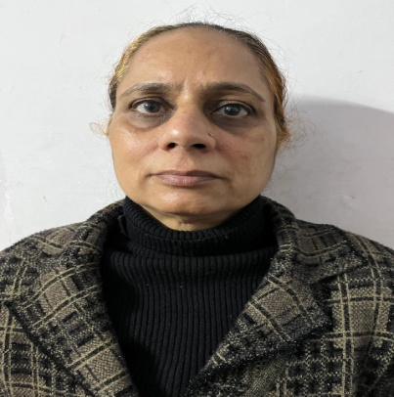
Department |  | Zoology
Designation |  | Associate Professor
Experience |  | 30 Years
Contact No |  | 9416101286
Email Id |  | grewalsunita@gmail.com
Date of Joining |  | 3 – July - 1995
Educational Qualification
 | Name of Program |  | Year of  Passing | University
PG | M Sc (Zoology) |  | 1990 | DEI, Agara
Ph.D. | Zoology |  | 1997 | KU, Kurukshetra
Net | GATE |  | 1990 | IIT, Delhi
Other | M. Phil (Zoology) |  | 1992 | KU, Kurukshetra
Research Supervision/Guidance |  | 5 M Phil Desertations
Research Publications |  | 12
Books Published |  | -
Book Chapters |  | -
Papers Presented in Conferences/ Seminar |  | International: - National: 4
Participated in Conferences/ Seminar |  | International: - National: 15
No. of Workshops/FDP/Training Programme Attended |  | NA
Major/Minor Research Projects |  | 1 Minor Research Project
Invited Lectures |  | 2
Awards/Honours |  | -
Membership of Any  Professional/ Statutory Body |  | Board of Studies MD University, Rohtak & CBL University, Bhiwani

